|  |
| --- |
|  |
| Quick Start Guide for MantisHub |
| Version 01.01.01 |



**Revision History**

|  |  |  |  |
| --- | --- | --- | --- |
| **Version #** | **Remark** | **Date** | **Done By** |
| 01.01.01 | Initial draft | July 30, 2015 | Pavan |
|  |  |  |  |
|  |  |  |  |
|  |  |  |  |
|  |  |  |  |
|  |  |  |  |
|  |  |  |  |

Table of Contents

1. Purpose 5

2. Definition(s) and Abbreviation(s) 6

3. Reference(s) 6

4. Overview 7

4.1 What is MantisHub? 7

4.2 What is MantisHub URL? 7

4.3 How it works? 7

5. Views 8

5.1 My View 9

5.2 View Issues 10

5.3 Report Issue 11

5.3.1. Reproducibility 11

5.3.2. Severities 12

5.3.3. Status 12

5.3.4. Priority 13

5.4 Change Log 14

5.5 Roadmap 15

6. Statuses 16

6.1 New 16

6.2 Feedback 16

6.3 Acknowledged 16

6.4 Confirmed 16

6.5 Assigned 16

6.6 Resolved 16

6.7 Closed 17

7. Reporting, Tracking, Assigning, and Resolving issues 18

7.1 Reporting 18

7.2 Tracking 18

7.3 Assigning 18

7.4 Add Note and Resolve issue 19

8. Filter/Search Issues 20

9. FAQs 22

1. How to see all Issues in single page? 22

2. How to see Open issues in single project? 22

3. How to see all Open issues from all projects? 22

4. How to see all issue ‘Assign To’ me in single project? 22

# Purpose

* The purpose of this document is to understand features of MantisHub and how to use.
* This document will provide the details of how to manage issues statuses in the MantisHub.

# Definition(s) and Abbreviation(s)

|  |  |
| --- | --- |
| **Name** | **Abbreviation** |
| MantisHub | Mantis |
|  |  |
|  |  |

Table #1

# Reference(s)

|  |  |
| --- | --- |
| **Document #** | **Title** |
| 1 | <https://mantisbt.org> |
|  |  |
|  |  |
|  |  |

Table #2

# Overview

MantisHub is web base bug tracking system. It is used for different projects with multiple users and roles. It allows you to track the progress of issue resolution for multiple projects and also saves information about all issue.

* 1. What is MantisHub?
  2. What is MantisHub URL?
  3. How it works?

## What is MantisHub?

* MantisHub is web base bug tracking system.

## What is MantisHub URL?

* “https://ds.mantishub.com”.

## How it works?

* Create an account on “https://ds.mantishub.com” and activate account by received mail and do login with valid credential.

# Views

In general, the views have either an “all projects” or a specific project context. You might stick with the “all projects” context to get an overview of all of your projects, but you would have to choose a specific project to report issues and perform other project specific tasks. Refer below image to select project.

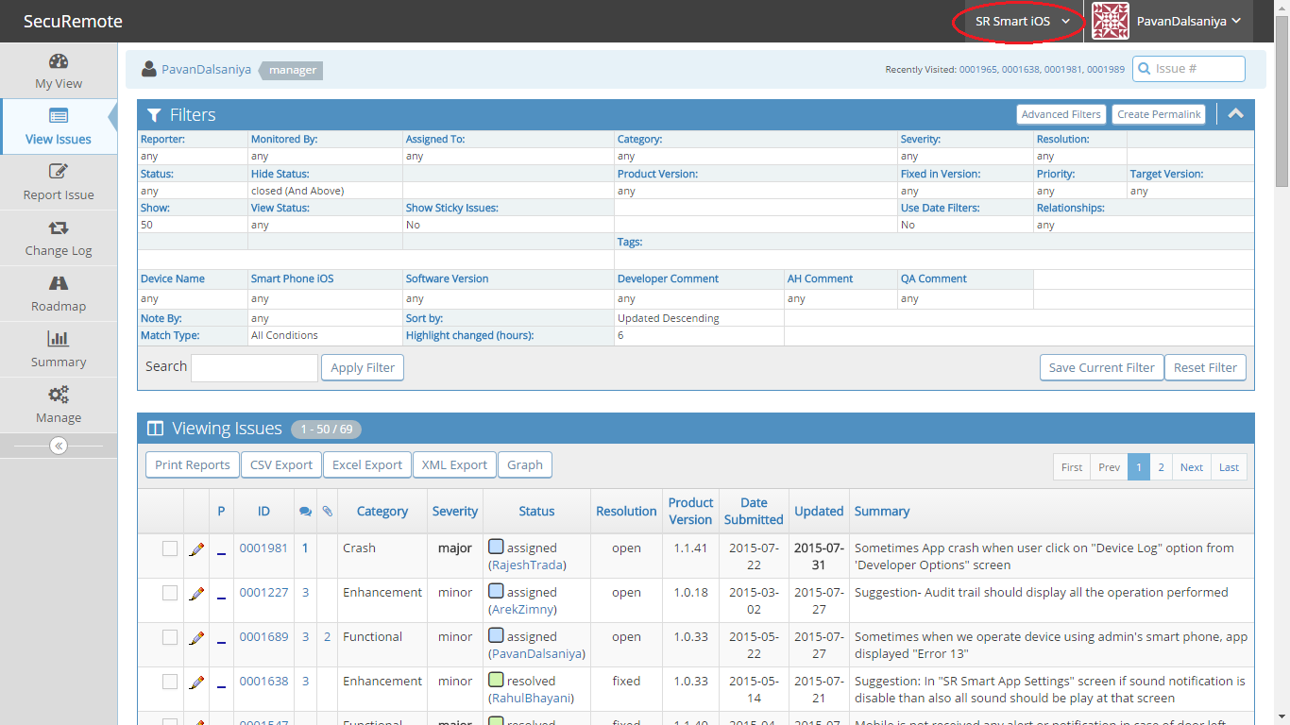

## My View

Issues pertinent to the particular user grouped by “Assigned to Me,” “Reported by Me,” “Recently Modified,” “Unassigned,” “Resolved,” and “Monitored by Me.”

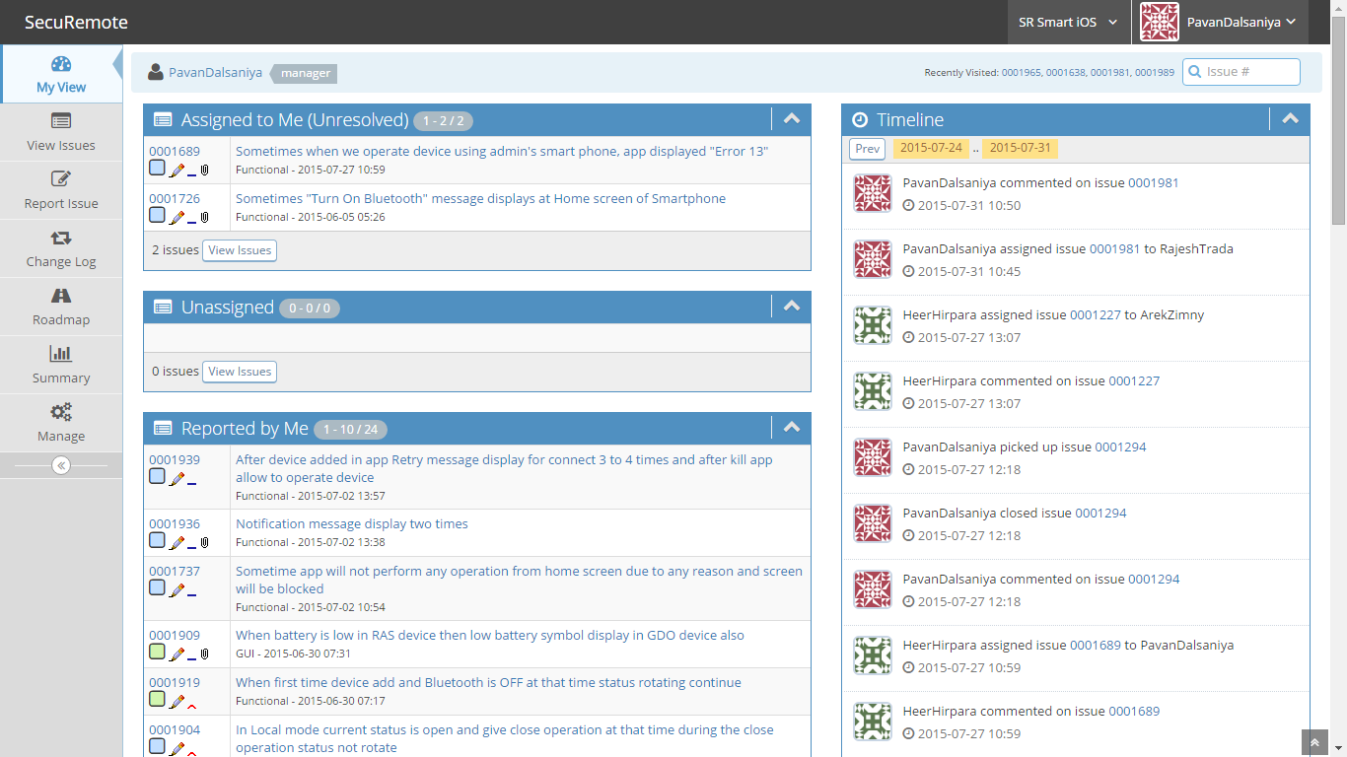

## View Issues

Issues viewed through custom filters. Nice screen that allows you to quickly work with multiple issues; for example, select all issues and assign them to a developer, or select a bunch of issues and set the priority to high.

From this view you can also choose to print reports for any of the issues. Reports can be generated in Excel or Word formats, and they include the history of a given issue.

Also, you can use Search, a traditional search-engine function, or Jump, which allows you to jump to a particular issue number.

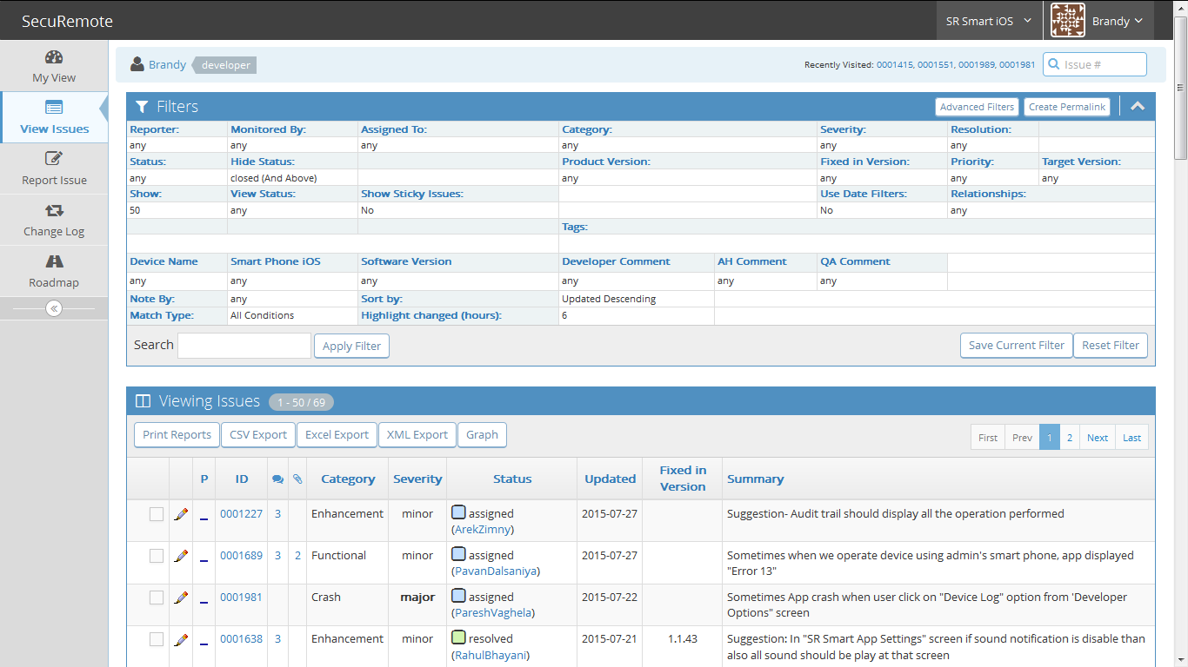

## Report Issue

Form to report an Issue page will display. User have to fill all mandatory information and click on “Submit Report” button to report an issue.

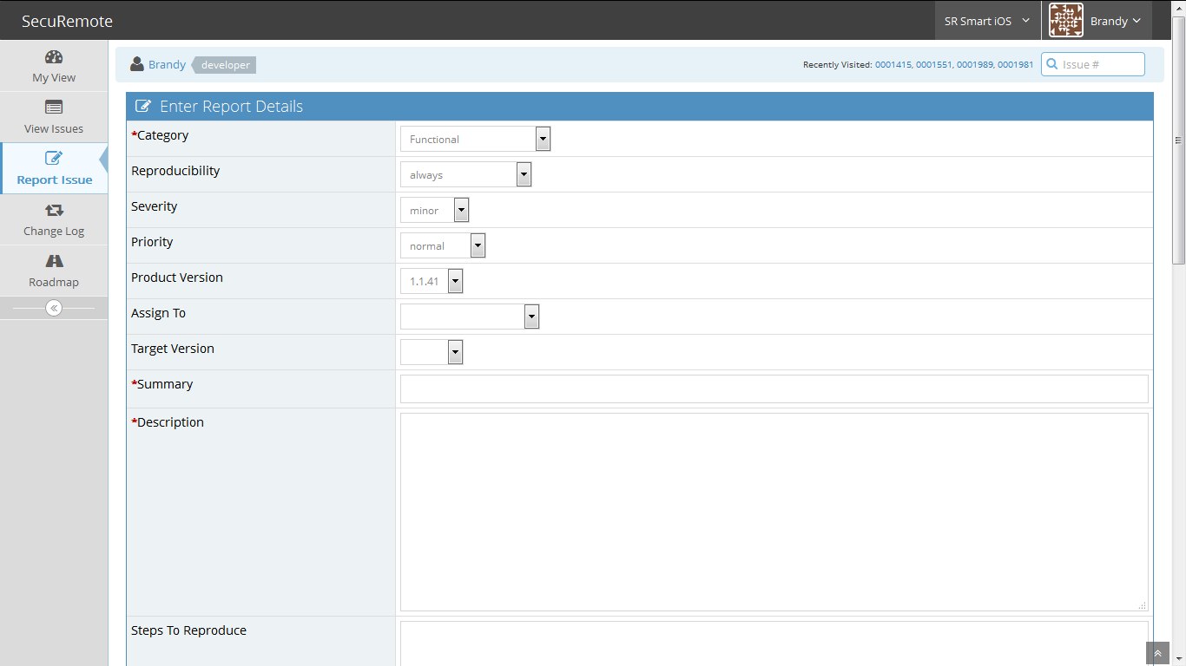



### Reproducibility

Each issue/bug needs to be classified as to the ability to reproduce it:

|  |  |
| --- | --- |
| **always** | the issue/bug is always there |
| **sometimes** | the issue/bug is reproducible but happens infrequently |
| **random** | the issue/bug is intermittent |
| **have not tried** | no one has tried to reproduce the issue/bug |
| **unable to duplicate** | the issue/bug has not occurred again since the initial reporting |
| **N/A** | this is a request for a new feature not an issue or bug |

### Severities

Issues may be assigned the following severity codes:

|  |  |
| --- | --- |
| **block** | Prevents further work/progress from being made |
| **crash** | Crashes the application or the OS |
| **major** | A major issue/bug; something doesn't work properly and affects the overall application without crashing it |
| **minor** | A minor issue/bug; |
| **tweak** | Needs tweaking or adjustment; positioning of a graphical object |
| **text** | Error in the text; spelling, punctuation, capitalization |
| **trivial** | Dis-agreement with wording, colors textures |
| **feature** | Request for a new feature |

### Status

The status of an issue/bug reflects where in its life cycle the issue/bug currently is.

|  |  |
| --- | --- |
| **new** | A new issue/bug |
| **feedback** | Issue/bug requires more information, the original posters should pay attention an add more information |
| **acknowledged** | The issue/bug has been looked at but not confirmed or assigned |
| **confirmed** | The issue/bug has been confirmed and reproducible; typically set by an Updater or a Developer |
| **assigned** | The issue/bug has been assigned to a developer for resolution |
| **resolved** | The issue/bug should be fixed, waiting on confirmation of a fix. |
| **closed** | Issue/bug has been verified as fixed and has been integrated into product |

### Priority

Priority represents the importance of fixing a bug.

|  |  |
| --- | --- |
| **None** | No priority set |
| **Low** | A defect with low priority indicates that there is definitely an issue, but it doesn’t have to be fixed to match the “exit” criteria |
| **Normal** | A defect having this priority it has to be fixed as it could also deal with functionality issues which is not as per expectation |
| **High** | A defect having this priority it has to be fixed for any test activity to match the “exit” criteria |
| **Urgent** | This has to be fixed urgently |
| **immediate** | This has to be fixed immediately within 24 hours |

## Change Log

Changes in versions, i.e. from version x to version y, here’s what changed.

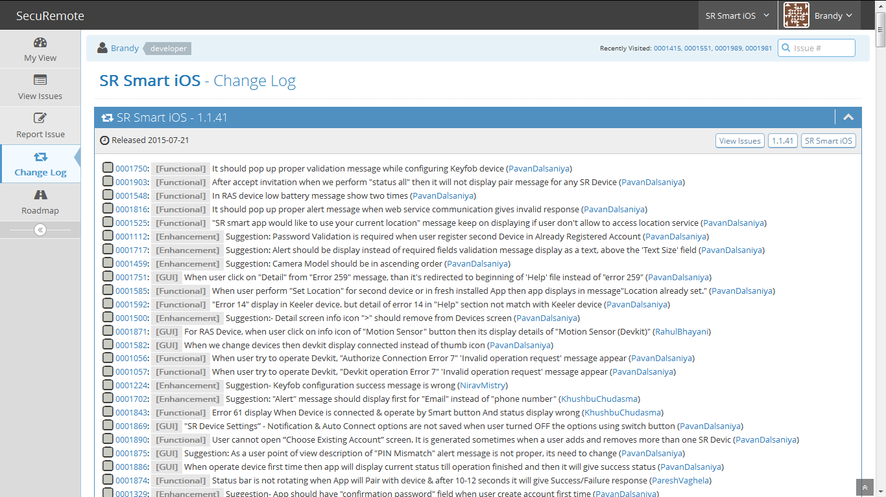

## Roadmap

Roadmap provide different project Scheduled for Release.

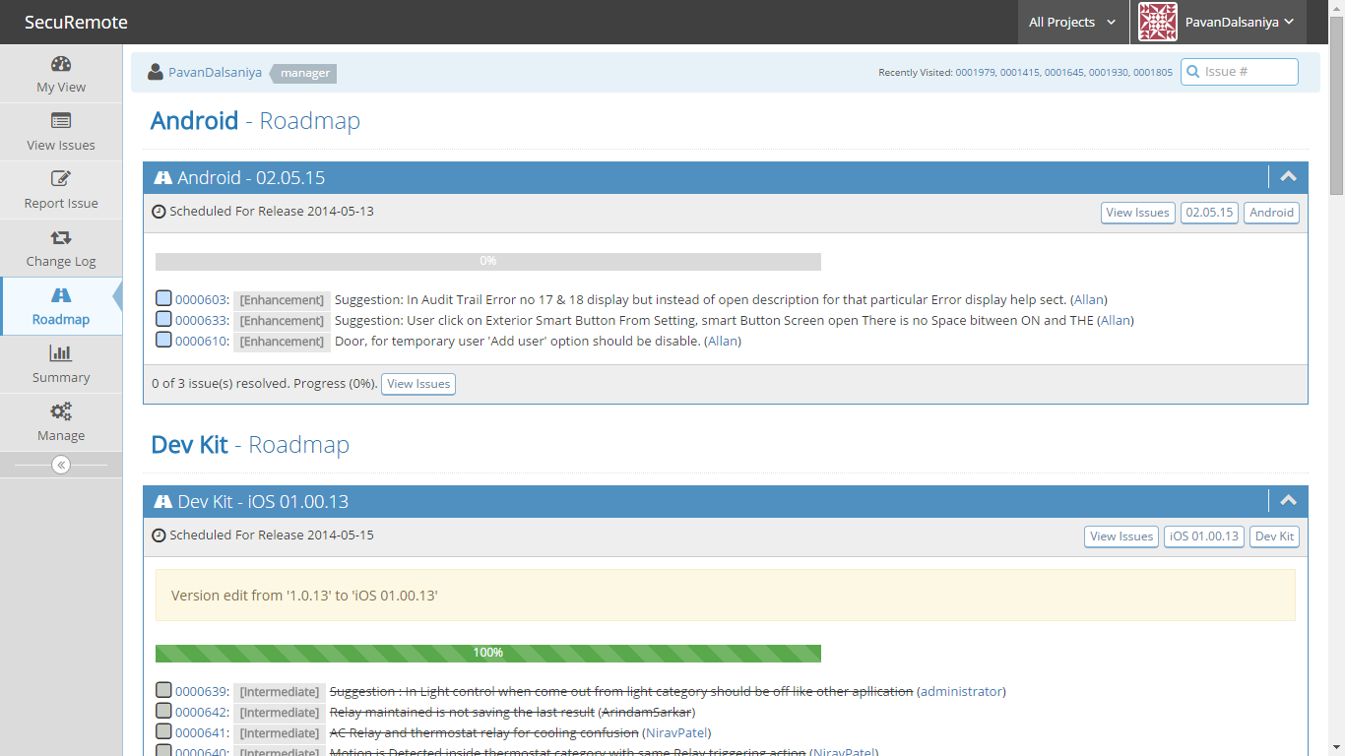

# Statuses

Mantis following statuses: new, feedback, acknowledged, confirmed, assigned, resolved and closed. In this case "new" -> "assigned" map to opened, "resolved" means resolved and "closed" means closed.

Following is the explanation about statuses.

## New

This is the landing status for new issues. Issues stay in this status until they are assigned, acknowledged, confirmed or resolved. The next status can be "acknowledged", "confirmed", "assigned" or "resolved".

## Feedback

This status is used when assigned team asks for more information to the reporter.

## Acknowledged

This status is used by the development team to reflect their agreement to the suggested feature request. Or to agree with what the reporter is suggesting in an issue report, although they didn't yet attempt to reproduce what the reporter is referring to. The next status is typically "assigned" or "confirmed".

## Confirmed

This status is typically used by the development team to mention that they agree with what the reporter is suggesting in the issue and that they have confirmed and reproduced the issue. The next status is typically "assigned".

## Assigned

This status is used to reflect that the issue has been assigned to one of the team members and that such team member is actively working on the issue. The next status is typically "resolved".

## Resolved

This status is used to reflect that the issue has been resolved. An issue can be resolved with one of many resolutions (customizable). For example, an issue can be resolved as "fixed", "duplicate", "won't fix", "no change required", etc. The next statuses are typically "closed" or in case of the issue being re-opened, then it would be "feedback".

## Closed

This status reflects that the issue is completely closed and no further actions are required on it. It also typically hides the issue from the View Issues page. Some teams use "closed" to reflect sign-off by the reporter and others use it to reflect the fact that the fix has been released to customers.

# Reporting, Tracking, Assigning, and Resolving issues

## Reporting

A user who is a Reporter and above can report issues to any project that is public, or that is private and to which s/he has access. Report an issue by clicking “Report Issue.” The fields are relatively self-explanatory. If you are browsing in an “All Projects” context, you’ll be forced to pick a project to report an issue for.

One excellent feature is the ability to upload files related to an issue. So a user can upload a screen shot if there is an error alert, or if there is a layout issue.

For more details refer topic 5.3 Report Issue .

## Tracking

There are several ways of tracking an issue. As indicated in the “Views” section above, you can view several issues in several different ways. You can also click on an issue number and choose “Monitor Issue”. This will put the issue into the “Monitored by Me” section of “My View.” You’ll also receive an email any time a change is logged for that issue (somebody updates the status, adds a note, etc.)

Any time a user clicks on an issue number to view the issue details, s/he can view and add notes to an issue, and change the status. This is a handy way for project managers to do a quick-check on an issue if they need an answer for a client.

## Assigning

Issues can be assigned to particular users who are Developers or above. When you assign an issue to a user, s/he receives an email notification. Managers and administrators can then send reminders for any given issue to the person to whom the issue was assigned. Refer below steps to assign issue to any developer.

1. Click on ‘Issue ID’ from “View Issues” tab and issue detail page will display.
2. Now select Assignee name from dropdown box which is right side of “Assign To: “button and then click on “Assign To: “button.

**Note: Refer topic** **6 Statuses** **for more details**

## Add Note and Resolve issue

A Developer can change the status of an issue to “Resolved.” A manager or administrator can mark it as “Closed.” By default, resolved issues show up in most views. Closed issues do not. Refer below steps to resolve issue.

1. Click on Issue ID from “View Issues” tab and issue detail page will display.
2. Select “Resolved” option from dropdown which is right side of “Change Status To:” button and then click on “Change Status To:” button.
3. Select “Fixed in Version” value from dropdown button.
4. Write Note and click on “Resolve Issue” button.

# Filter/Search Issues

User can filter issues from Search. User can filter issues from single project as well as ‘All Projects’. It is depend on Select project name from Project Dropdown. See default filter value in below figure.

If Search panel is Hidden then click on down arrow icon so filter will show all the fields. When you want to hide search panel then click on up arrow icon. See Below Figure 1: Filter/Search panel is hidden.

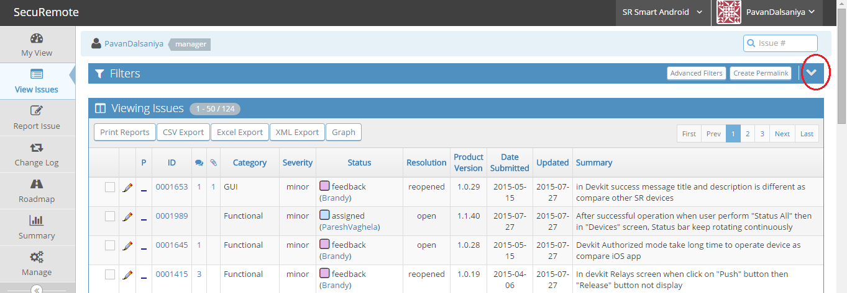

Figure 1 : Filter/Search panel is hidden

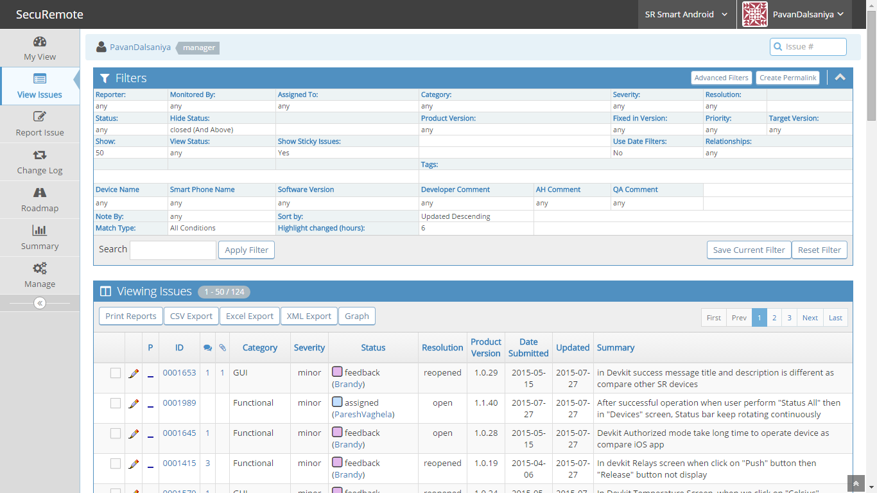

Figure 2 : Default value set in filter/Search

User can filter the entire field given in Search panel and user can get result depend on the set values in every fields. User can search result with one field or more fields. Refer Figure 3: Filter/Search Issues.

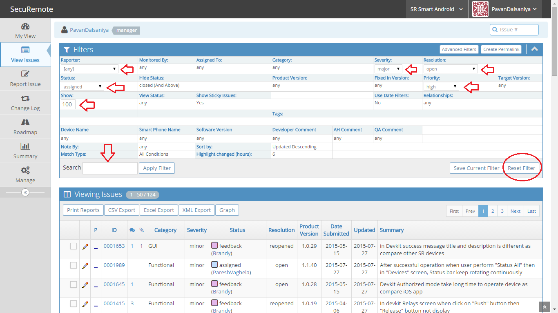

Figure 3 : Filter/Search Issues

* User can set Single value for every Fields in ‘Simple Filter’.
* In Advance filter you can select multiple values from every Fields.
* After choose any value for every field, It is mandatory to click on ‘Apply Filter’ button else filter will not affect to result.
* Click on ‘Reset Filter’ button when you want to clear filter. And it will show default value set in all field. Refer Figure 2 : Default value set in filter/Search.
* Search textbox allow search text for ex. Write some word in textbox and click on ‘Apply Filter’ button so if it found that text from issue then give match result.

# FAQs

## How to see all Issues in single page?

First select project from drop down for ex. ‘UDI/SR Portal’. Now click on ‘Show’ link in search and enter 200 and click on ‘Apply Filter’ button. So it will show 200 issues in same page if available.

## How to see Open issues in single project?

First select project from drop down for ex. ‘UDI/SR Portal. Now click on ‘Resolution’ link and select ‘Open’ value from dropdown list and click on ‘‘Apply Filter’ button. Make sure no other field is selected otherwise it show different result.

## How to see all Open issues from all projects?

First Select project from drop down for ex. ‘All Projects’. Now click on ‘Resolution’ link and select ‘Open’ value from dropdown list and click on ‘‘Apply Filter’ button. Make sure no other field is selected otherwise it show different result.

## How to see all issue ‘Assign To’ me in single project?

First select project from drop down for ex. ‘UDI/SR Portal. Now click on ‘Assign To’ link and select your name from dropdown list and click on ‘‘Apply Filter’ button. Make sure no other field is selected otherwise it show different result.